Conditional Probability

The formula for conditional probability is[1]:

P(B|A) = P(A and B) / P(A)

which you can also rewrite as:

P(B|A) = P(A∩B) / P(A)

Example 1

In a group of 100 sports car buyers, 40 bought alarm systems, 30 purchased bucket seats, and 20 purchased an alarm system and bucket seats. If a car buyer chosen at random bought an alarm system, what is the probability they also bought bucket seats?

Step 1: Figure out P(A). It’s given in the question as 40%, or 0.4.

Step 2: Figure out P(A∩B). This is the intersection of A and B: both happening together. It’s given in the question 20 out of 100 buyers, or 0.2.

Step 3: Insert your answers into the formula:

P(B|A) = P(A∩B) / P(A) = 0.2 / 0.4 = 0.5.

The probability that a buyer bought bucket seats, given that they purchased an alarm system, is 50%.

[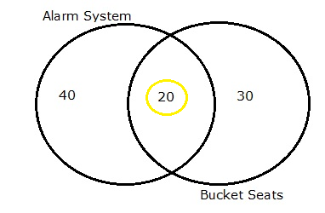](https://www.statisticshowto.datasciencecentral.com/wp-content/uploads/2012/10/venn-diagram-of-conditional-probability.png)

*Venn diagram showing that 20 out of 40 alarm buyers purchased bucket seats.*

Example 2:

This question uses the following [contingency table](https://www.statisticshowto.datasciencecentral.com/what-is-a-contingency-table/):

[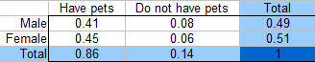](https://www.statisticshowto.datasciencecentral.com/wp-content/uploads/2012/10/conditional-contingency.png)  
  
  
What is the probability a randomly selected person is male, given that they own a pet?

Step 1: Repopulate the formula with new variables so that it makes sense for the question (optional, but it helps to clarify what you’re looking for). I’m going to say M is for male and PO stands for pet owner, so the formula becomes:

P(M|PO) = P(M∩PO) / P(PO)

Step 2: Figure out P(M∩PO) from the table. The intersection of male/pets (the intersection on the table of these two factors) is 0.41.

[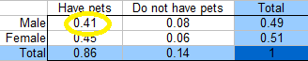](https://www.statisticshowto.datasciencecentral.com/wp-content/uploads/2012/10/conditional-contingency3.png)  
  
Step 3: Figure out P(PO) from the table. From the total column, 86% (0.86) of respondents had a pet.  
[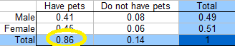](https://www.statisticshowto.datasciencecentral.com/wp-content/uploads/2012/10/conditional-contingency2.png)  
  
Step 4: Insert your values into the formula:

P(M|PO) = P(M∩PO) / P(M) = 0.41 / 0.86 = 0.477, or 47.7%.

1. Taken from <https://www.statisticshowto.datasciencecentral.com/what-is-conditional-probability/>